Literals(1,2,@,*) values are fixed they are universal

Variables(a=10) value assigned by us

Identifies(main,int)

Java, C++ , Python are typed languages we must tell what type of data we are giving

JavaScript are non typed languages

Data Types:

Primitive [already exist in java] {8 types} (byte,short,char,int,long,float,boolean,double)

Non-Primitive[they store multiple values in them] (string , array, class , object)

byte - only 256 numbers it can print {-128 to 127}

char - only single characters like {'a','b','@','%'}

boolean - True or False

float - decimal with short range

int - numbers with short range {-2bn to +2bn}

long - integers with long range

double - decimals with long range

short

1byte = 8 bits

Why ... we have created this data types for space optimisation

byte , boolean - 1 byte

short , char - 2 bytes

int , float - 4 bytes

long , double - 8 bytes

Strict language restrictions is equal to strict security

Input in Java

next - single word input

nextLine - complete sentence has input

nextInt

nextFloat

nextlong

Type Conversion / Widening Conversion / Implicit Conversion

: Taking short space data type and storing large space data type

destination type > source type

Lossy Conversion if above statement is reverse

byte -> short -> int -> float -> long -> double

char -> int = results in ASCII conversion of characters

Type Casting / Narrowing Conversion / Explicit Conversion

: Knowingly accepting the case of Lossy Conversion

Type Promotion In Expressions*

: Java automatically promotes each byte,short or char operand to int when evaluating an expression.

If one operand is long, float or double, the whole expression is prompted to long float a double, respectively.

Types of Operators:

Arithmetic operators perform mathematical operations such as addition and subtraction with operands.

Unary operators perform an action with a single operand. Binary operators perform actions with two operands.

Arithmetic operators:

-> addition, subtraction , multiplication , division ,modulo , power

Binary operators(we need min 2 values to performs operation):

+ , - , * , / (quotient), %(remainder)

Unary operators(we need one value to perform operation):

++ , --

pre increment ++a value change and after value use

post increment a++ value use and after value change

Relational operators:

==

!=

>

<

>=

<=

Logical operators:

&& –AND

|| - OR

! - NOT

Bitwise operators:

Bitwise OR (|), Bitwise AND (&) ,Bitwise XOR (^) ,Bitwise Complement (~)

Assignment operators:

=

+=

-=

*=

/=

Ternary operators?

variable = (condition)? statement1 : statement2;

Shift operators

>> , <<

Note: For negative bits, the signed and unsigned right shift operators provide different results.

—-------------------------------------------------------------------------------------------------------------------------

Operator Precedence Table**

IF and Else

Switch (break,default)

While

For

do

break

continue

prime number ** range for(int i=2 , i<=sqrt(n) , i++) ; n%i == 0

pattern**

methods are those functions which were written in a class

parameters : at function

arguments : at function call

java uses calls by value : just gives a copy of value

c++ uses call by reference : gives the entire original control

function overloading : multiple functions with same name but different parameters,types ...nothing with the return type... by java

Binary to decimal:

Last digit , pow (2) , sum , n%10 , rem

Decimal to Binary:

Divide by 2

Last digit , pow(10) , sum , n%2 , rem

Scope:

Method Scope: in which function the variable is declared there itself we can use it,not in remaining functions.And also the variable must be declared before it is called rather than after statement calling and declaring it.

Block Scope: same thing in but instead of function , it is {} ,ex: for loop

Palindrome number : 121 = reverse 121 ; 123 != reverse 321;

Advanced Patterns:

See how many lines u wanna print for i loop

For matrix create j loop and inside it , it is in the form matrix now

Write all the possible things to get that shape by analyzing what is going on each line

Write down in 1st line which dealt loop i what is happening and second line what is the condition like that and bring it down and write in the terms i and n and put that condition in j loop

Don't forget code for next line in i loop

Hollow shape pattern go for matrix logic +in matrice’s (i,j) find common pattern

Solid shape pattern go for matrix logic + each line what it is printed and get logic for i loop how many times it must run and j loop on what condition it must run how many times and count and spaces and stars and bring it (n-i) logic

For mirror image in butterfly pattern kinda images try mirror the j loop by i changing i loop condition to (i=n;i>=1;i - -)

Pyramid pattern try to divide into parts such as spaces + other part some logic + another part with some other logic and try to see pattern in one each line

Hollow Loops:

****

* *

* *

****

Think it as a matrix and 2 for loops stating i and j such that loop acts has a matrix now

And get the common logic by putting paper and pen.for this question either i , j =1 and

i ,j= cols and rows and put this condition in an if loop .

Inverted pyramid Pattern:

*

**

***

****

Only one n entry needed

Three for loops

.,i for loop for rows

., one j for loop for cols for spaces , j till n-i

., another j for loop for cols for * , row no= no. of stars to be printed , j <=i

,. And next line

Inverted with numbers:

12345

1234

123

12

1

,i loop normally is no . of loops

, j loop condition is n-i+1, since,write down for each line i , how many numbers are getting printed…..

Floyd’s Triangle:

1

23

456

Normal star itself but just initialize a counter variable which the track of number

And print and do counter++ in j loop

Even n is enough

0-1 Triangle:

1

01

101

0101

10101

Matrix logic ,

Outer loop

n lines

Inner loop

Row+col no . = even print 1

Row + col no = odd print 0

j=1,j<=i,j++

Butterfly pattern:*

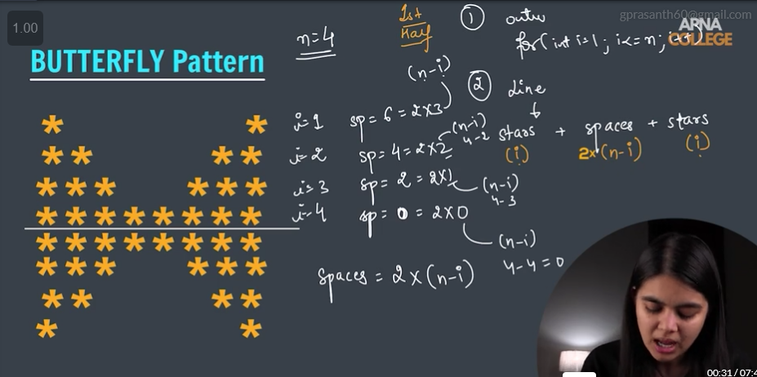

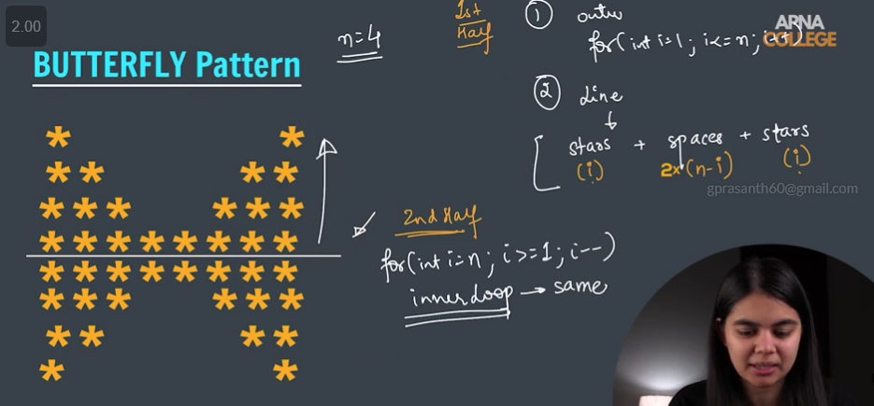

Solid Rhombus:

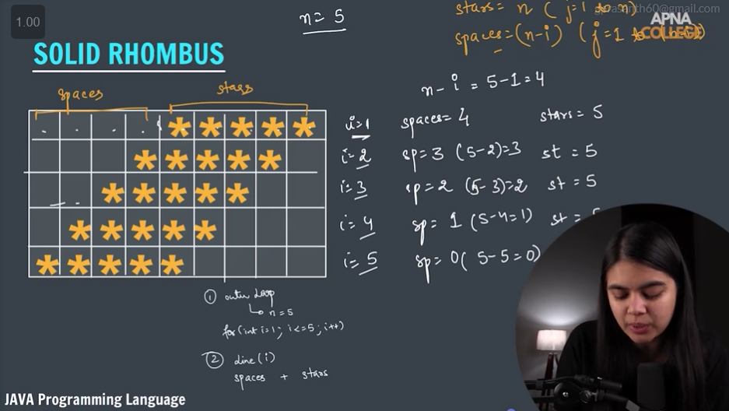

Hollow Rhombus:

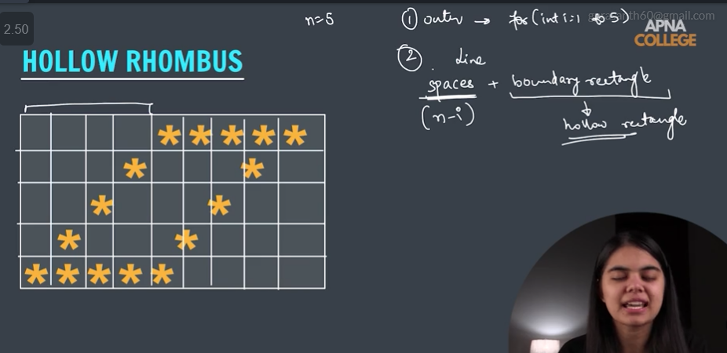

Diamond:

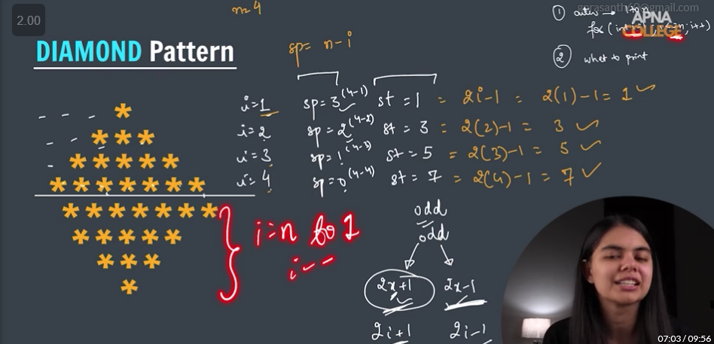

Palindromic Pyramid:

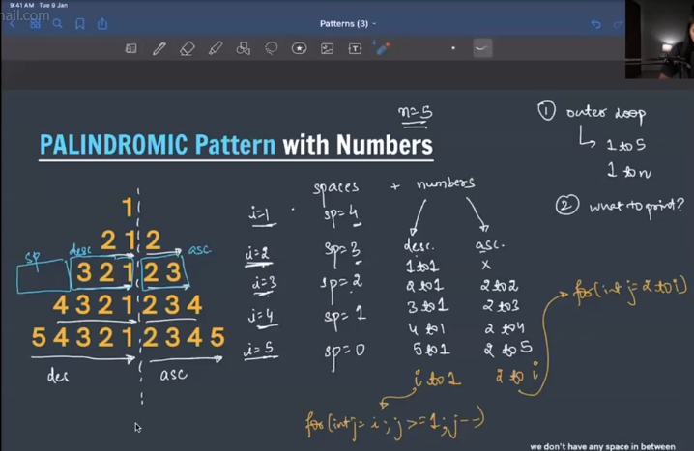

ARRAYS:

C++ , java works with 0 based indexing of an array

List of elements of the same type placed in a contiguous memory location

Format:

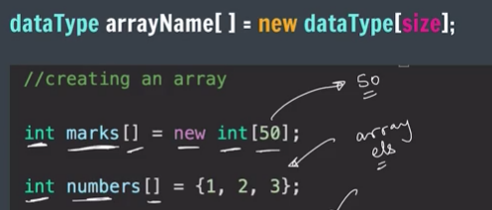

for(int i=0;i<arrayname.length;i++)

int num = Integer.MIN_VALUE; //-infinity

int num = Integer.MAX_VALUE; //+infinity

Length of the array = arrayName.length

Arrays in java work on basis of call by reference i.e., in one function a value got updated and another function it is called then value gets changed , generally usage of variables in java wont work on that way

Linear Search

Normal for loop to all elements check if condition return index

TC: O(N)

Binary Search

The array must be sorted array already either in desc or asec

Takes mid and compares the value

We don't use for loop ; we use while and if conditions intialsing the start=0,

end=arr.length-1 , while(start<=end) this shortens the array; start = end is the last case of the array,three if conditions num[mid]==key returns , otherwise num[mid]<key this is key is greater so it lies on the right of the array so start = mid+1 else mid -1 obviously it is less than num[mid]

TC: O(log n) , since in every iteration it n,n/2,n/4,n/8………1 so from last case

n/(2^k) = 1 so k = (log n)

Reverse Array

Create a temp var and through swap process just interchange it

Pairs in an Array:

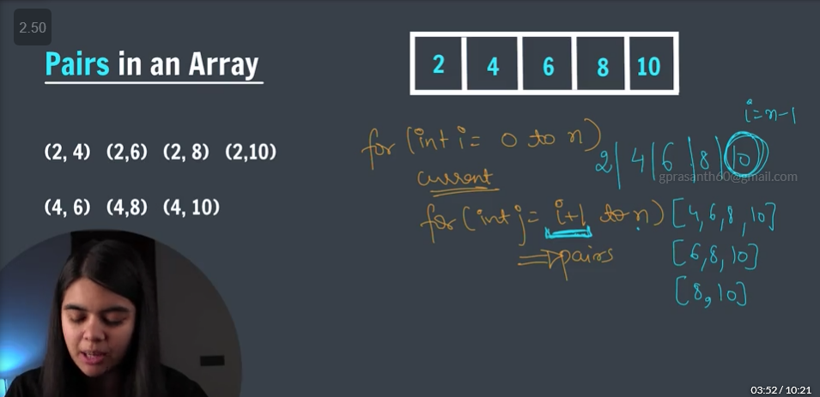

Total no. of pairs : n*(n-1) / 2

TC: O(n^2)

Sub Arrays:

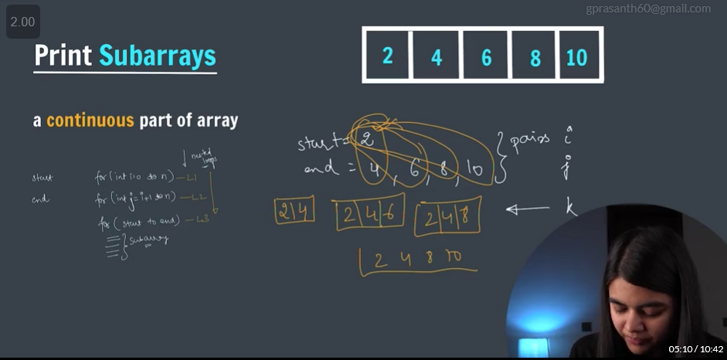

Total no. of sub arrays: n*(n+1) / 2

******

Max Subarrays brute force: O(n^3)

Max Subarrays prefix sum: O(n^2)

Kadane’s Algorithm: O(n)

Trapping Rainwater:

Trapped = (water level - height)*width

Auxiliary Arrays

Left Max Boundary

Right Max Boundary

Sorting Algos:

Bubble Sort:

Swap the elements by taking the 0th element and comparing it with its adjacent element until it is in its right position.

Large elements come to the end of the array by swapping with adjacent elements.

Even if we give a sorted array we will get TC= O(n^2) , so we add a swap++; so even after some swaps it didn’t change we can say it is a sorted array.

Many Swaps takes place

Selection Sort:

Pick the smallest (from unsorted), put it at the beginning.

We will divide the array into sorted part and unsorted part and push elements to the sorted from unsorted by taking least in it.

TC = O(n^2) but less swaps than bubble sort.

Insertion Sort:

Pick an element (from unsorted part) & place it in the right position in sorted part.Just like cards game

TC=O(n^2)

Inbuilt Sort:

TC = O(n logn)

Arrays.sort.(arr) : Ascending order

Arrays.sort.(arr,starting index,ending index) : to sort those particular row of elements only.

Arrays.sort(arr,Collections.reverseOrder()) : for descending order it is inbuilt one for object classes . so change int to Integer.

Arrays.sort.(arr,starting index,ending index ,Collections.reverseOrder())

Counting Sort:

For +ve elements , range of arr should be short , quantity is more like marks of students

For negative treat the values as positive and change greater and min functions accordingly.

2D-array:

Storage of elements in 2d arrays is different , might be in contiguous fashion

It stores as row major and column major

Row Major:

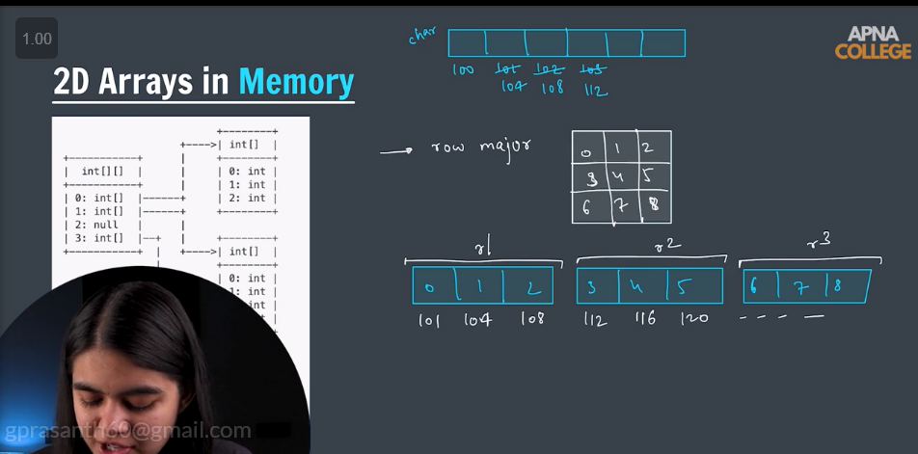

Col Major:

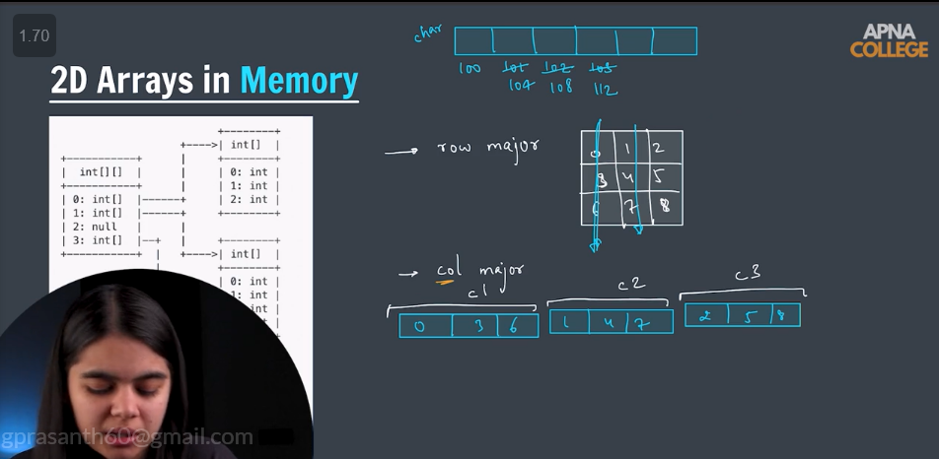

Spiral Matrix:

Well go with the outer boundary and reduce one step and again outer boundary

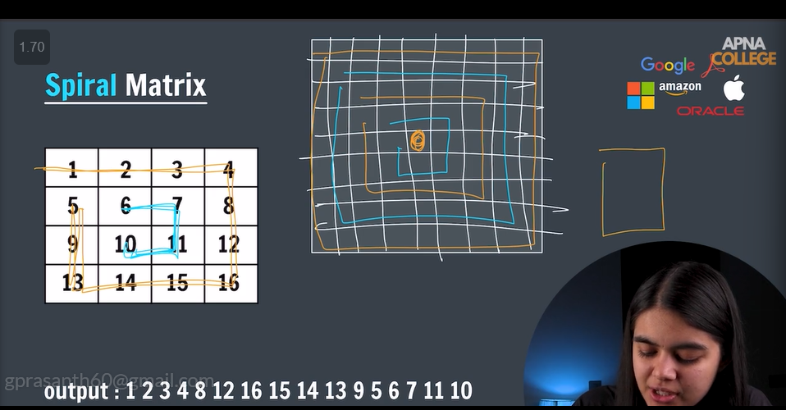

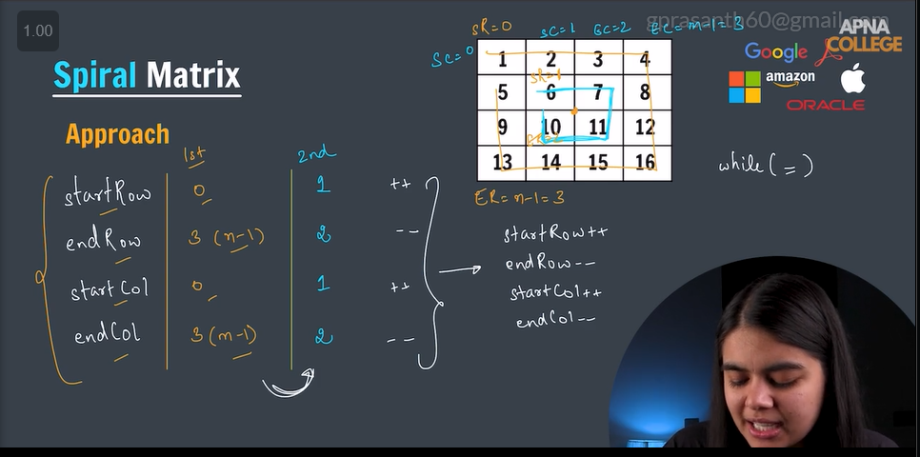

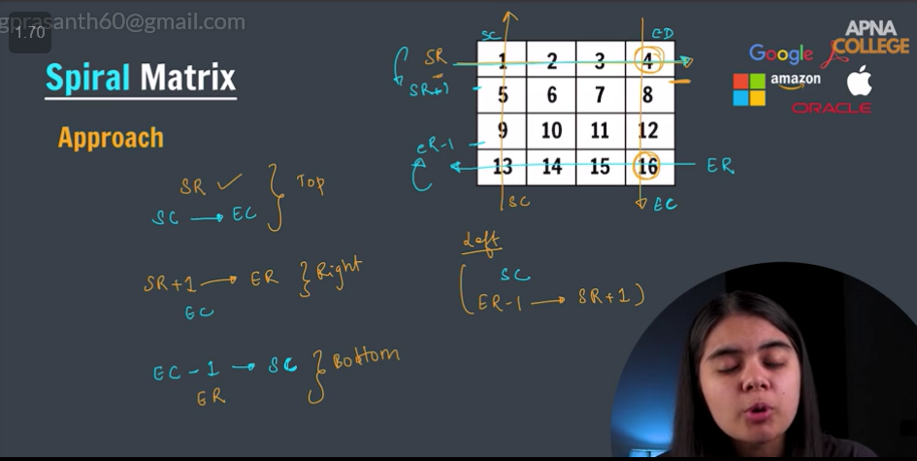

Diagonal Sum

We will solve for only nxn matrix

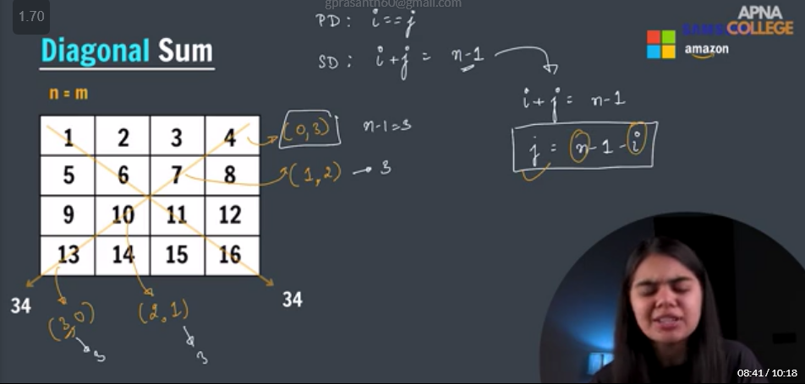

Search in sorted matrix

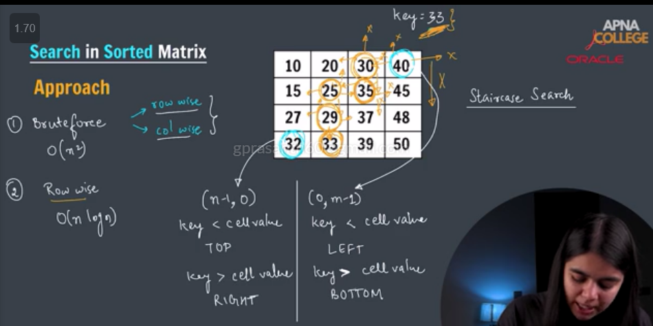

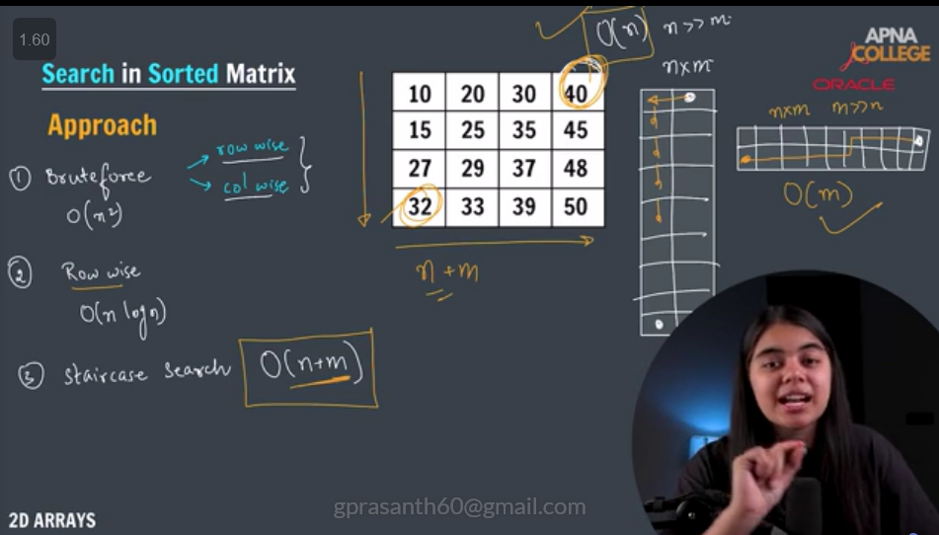

Strings

> java strings are immutable i.e, we can't do any changes with old string a new string is created with change if wanted

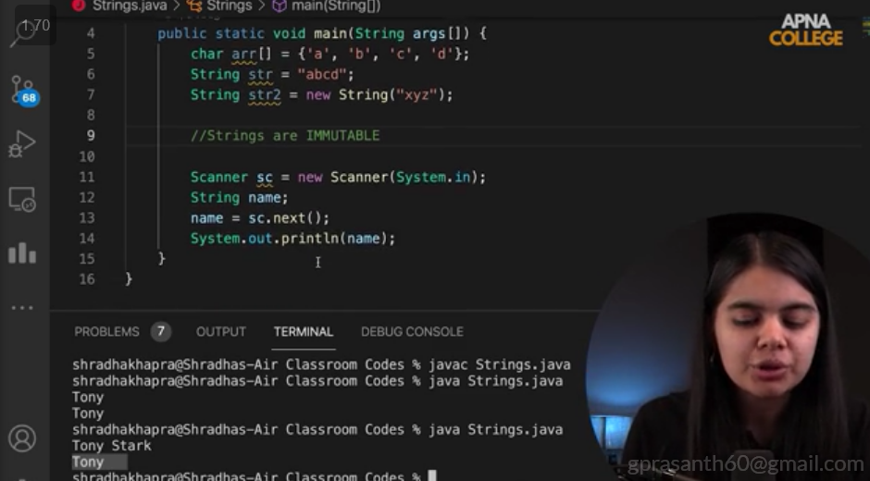

>general next for single word .

> nextLine for the entire sentence .

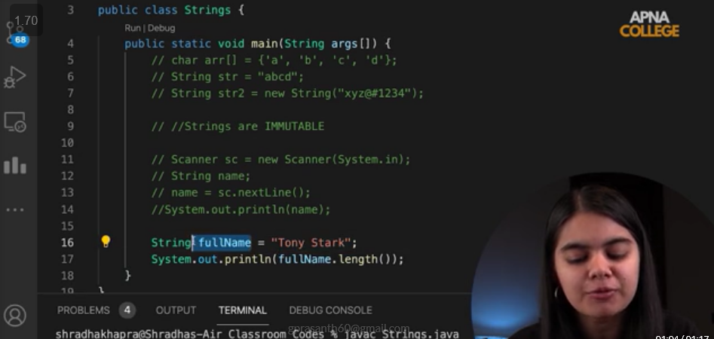

> In string.length space will be also counted.

> Concatenation = joining two words

> 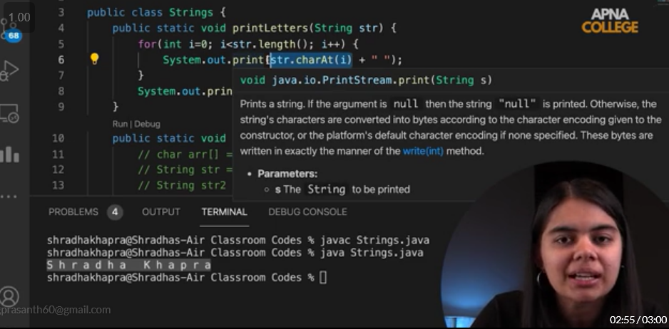

> CharAt for character at specified index

> 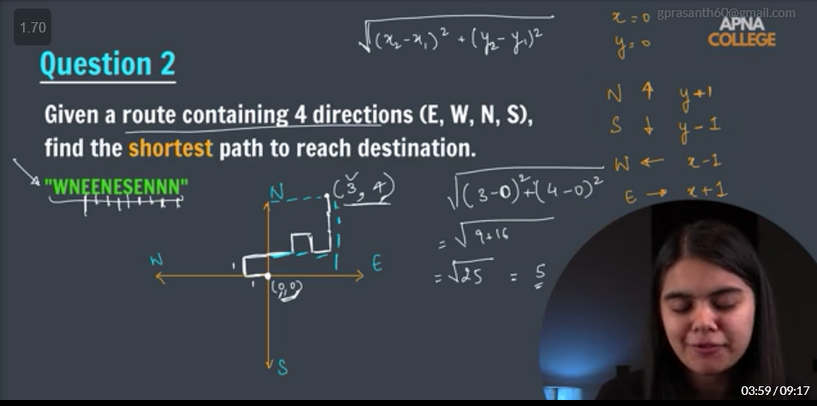

>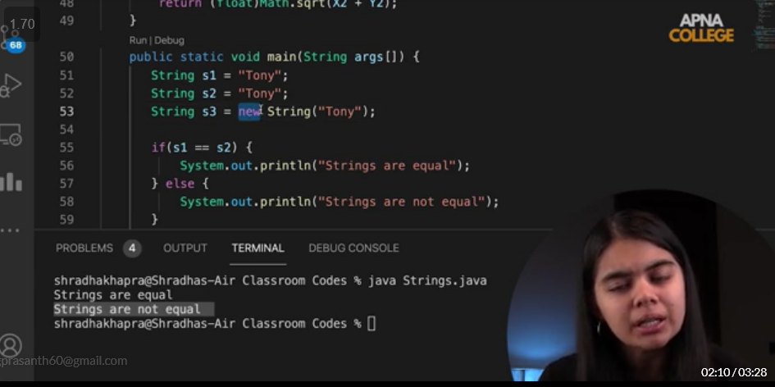 // Check this one

> when strings need to be compared ..we must not assign **new String .** since“==“ checks strings at the object level only .

> 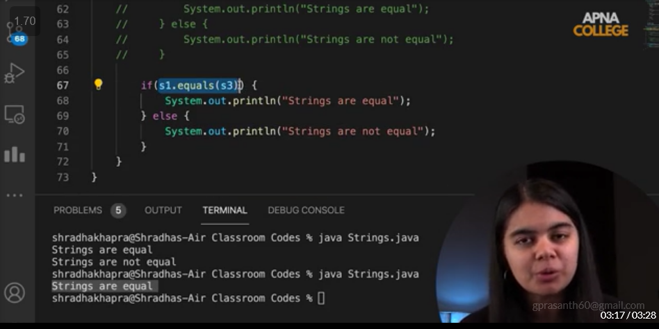

> if we wanna compare anything not the object level then we must use “equals”.

> Substring

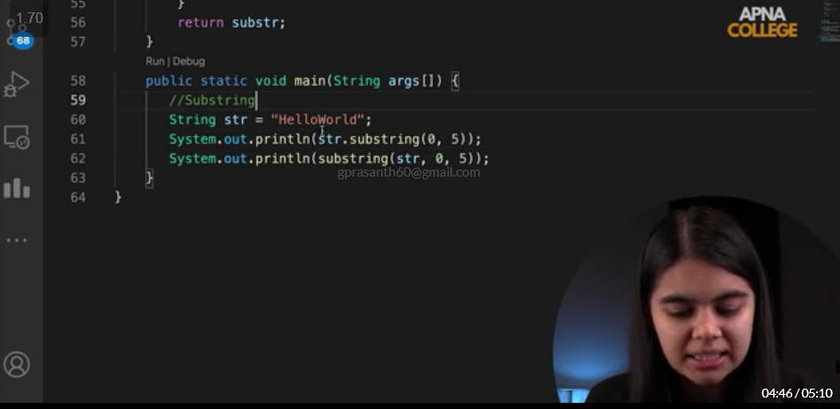

>Compare to and Compare to ignore case

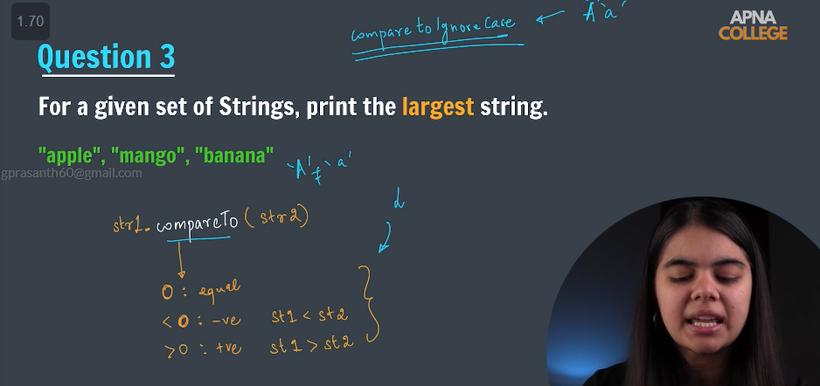

> interning (imp concept )

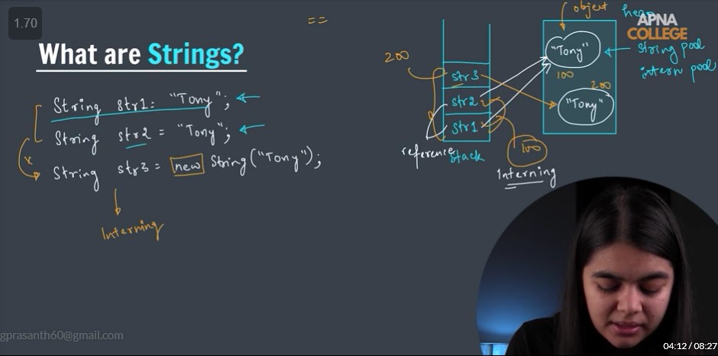

> strings are immutable

> 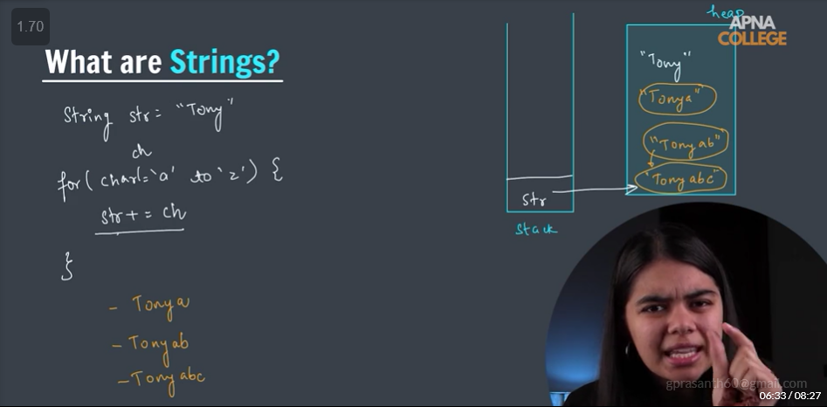

> it is inefficient to use strings when we want to modify the string every time . cause it copies the previous object and modifies and points it and TC increases. Therefore we use a string builder.

>

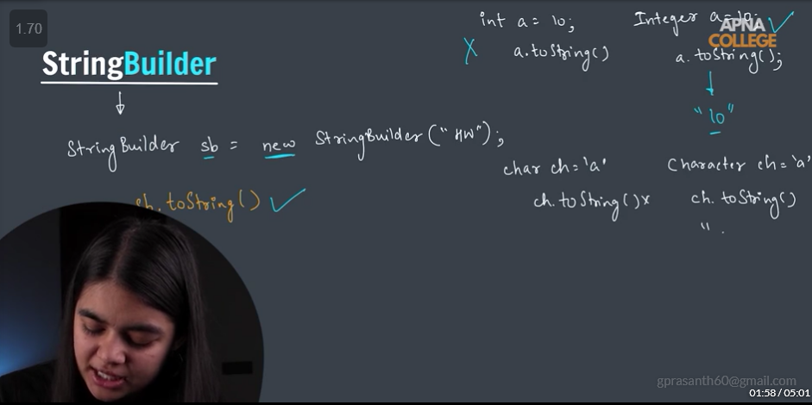

> String to uppercase

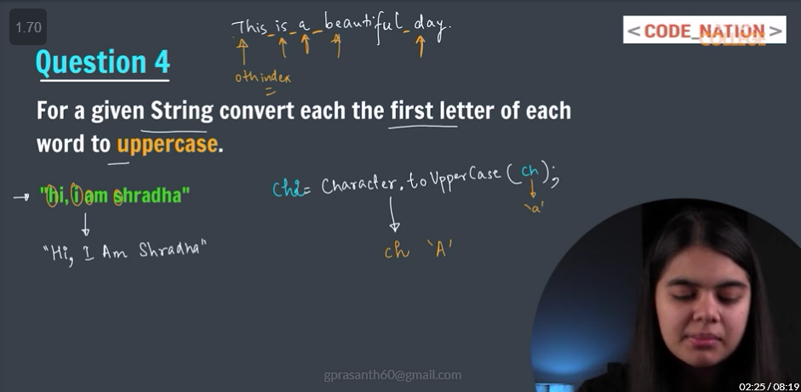

>string compression ***8

> character array and string buffer and anagrams

>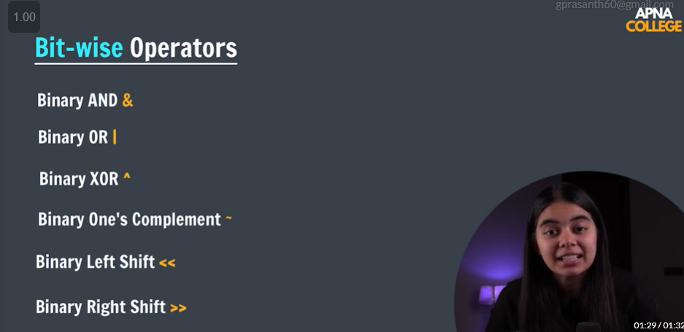

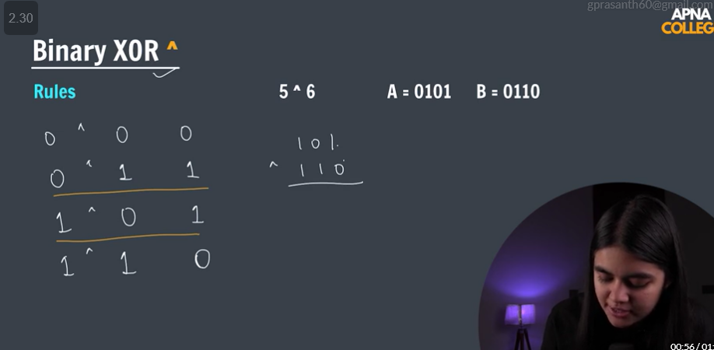

Least significant and ot significant bits

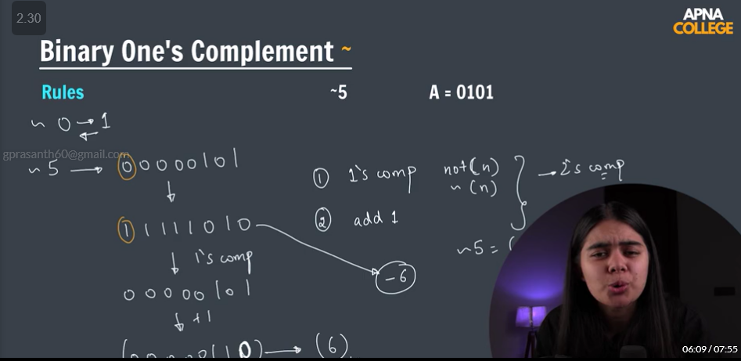

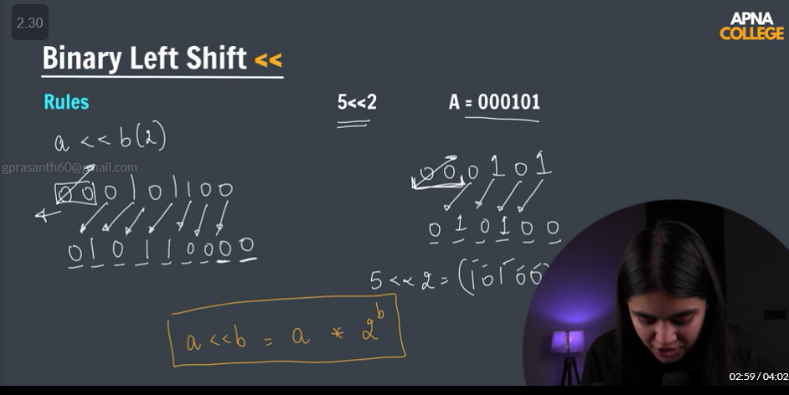

> imp formula

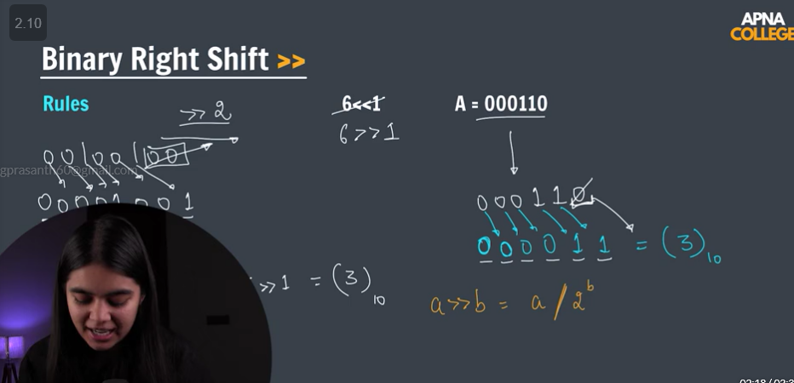

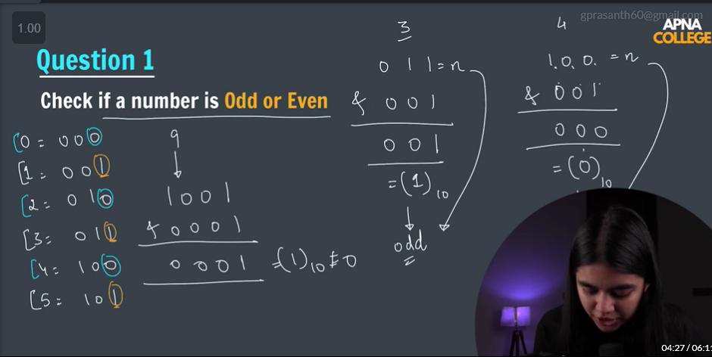

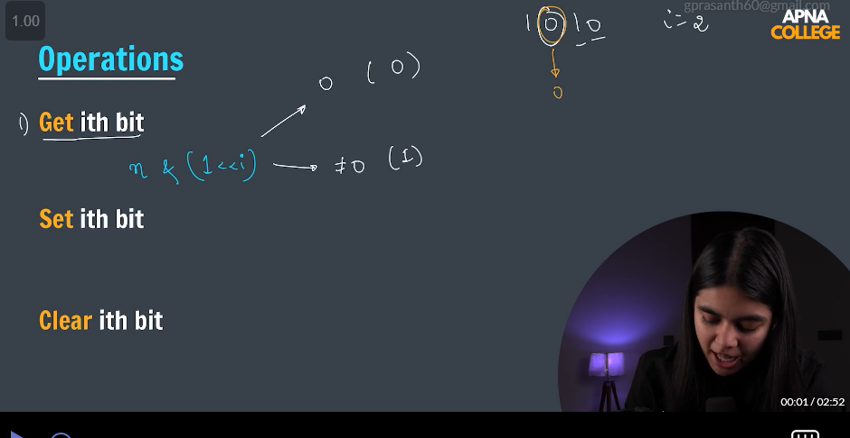

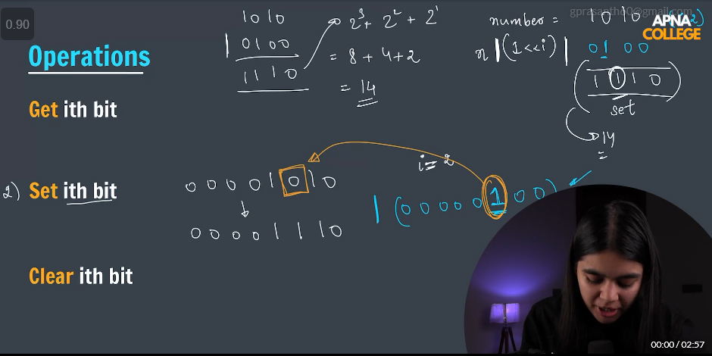

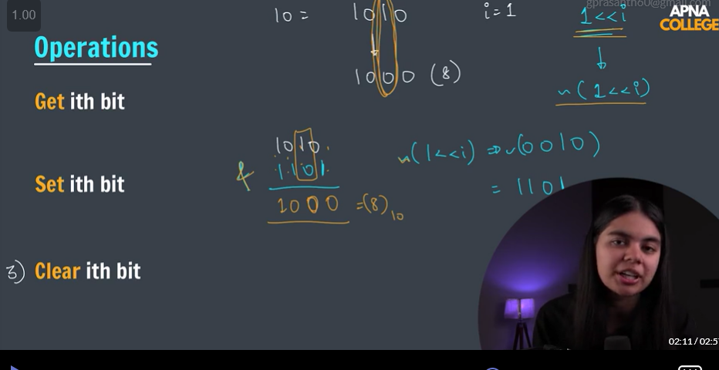

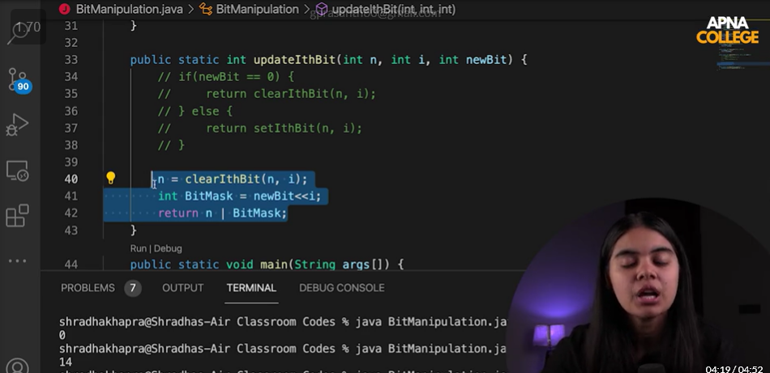

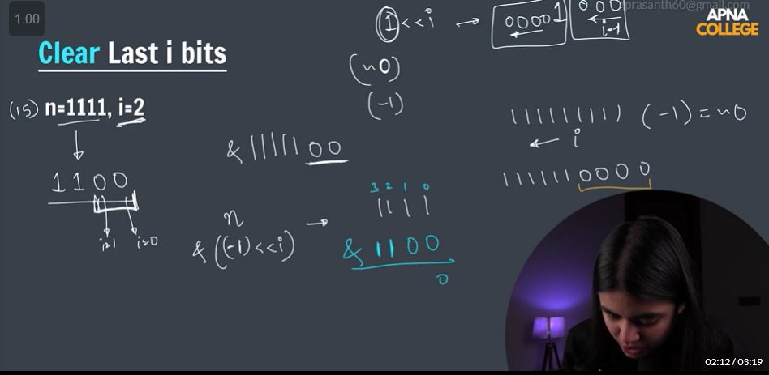

OOPS

>class is a blueprint of object,

> 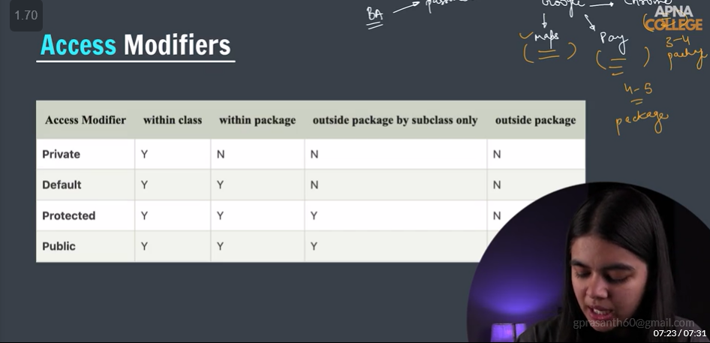

>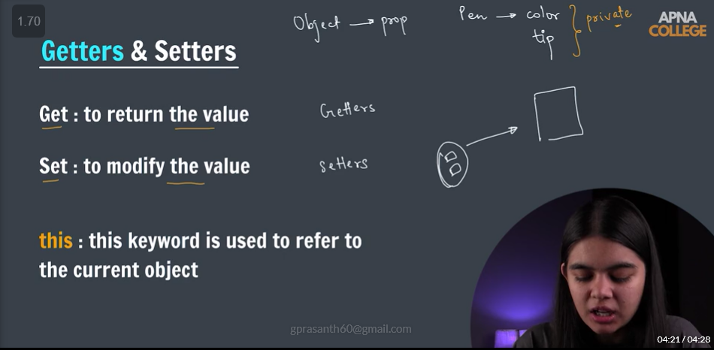

> Encapsulation

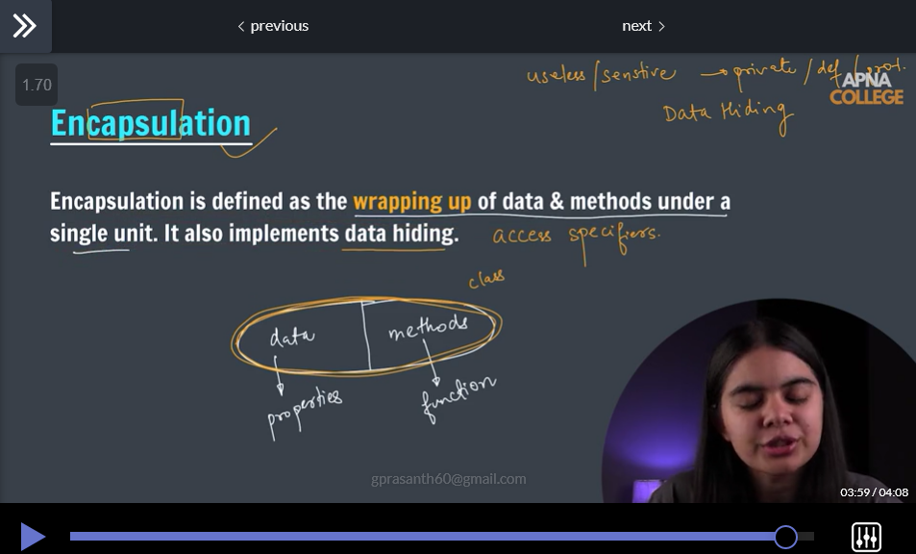

> Constructor

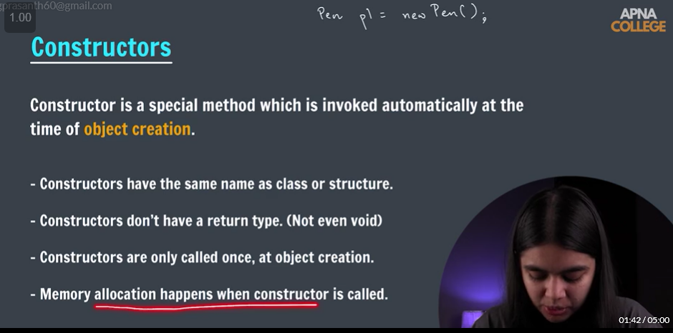

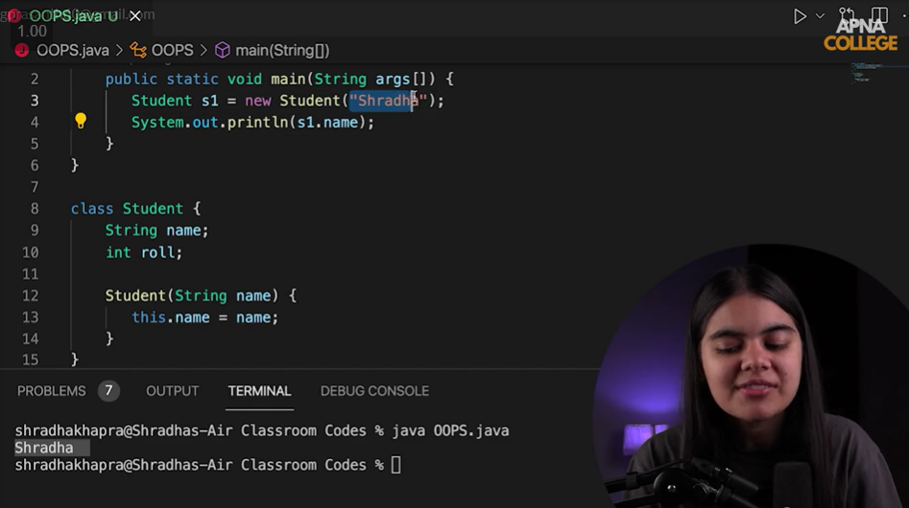

> Types of Constructor:

1. Non - parameterized
2. Parameterized
3. Copy constructor

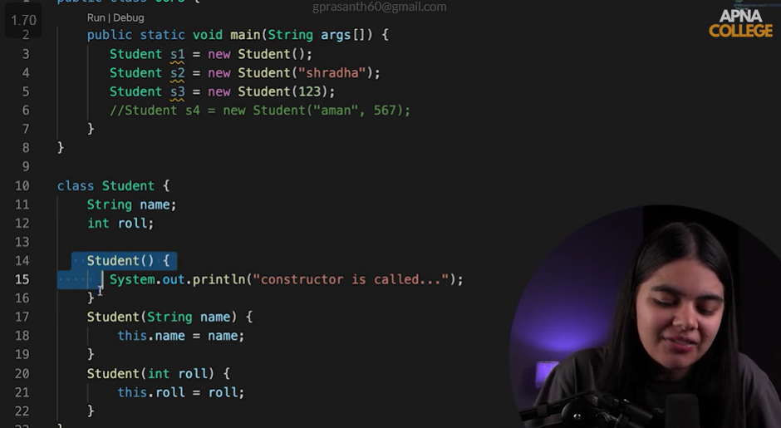

> Constructor Overloading ***

>

Recursion:

> Recursion is a method of solving a computational problem where the solution depends on solutions to smaller instances of the same problem .

> steps

1 Base Case

2 working of the function

3 call of inner function

>Stack overflow = base case is imp since , if it is not there then function calling will exceed and don’t know where to stop.

>

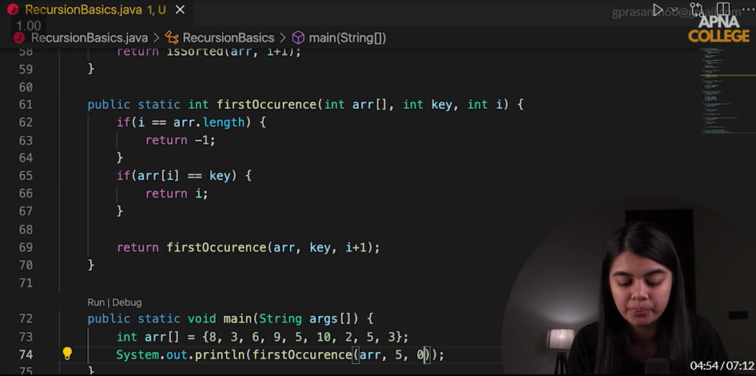

Imp step return (arr , key , i+1)************

>

Divide and Conquer:

>Merge Sort:

Calculating of mid

Mid = (si+ei)/2

Mid = si + (ei-si)/2 ( we use this case when the data-type raise the case overflow (datatype limit will be reached)when we have large array to deal with

>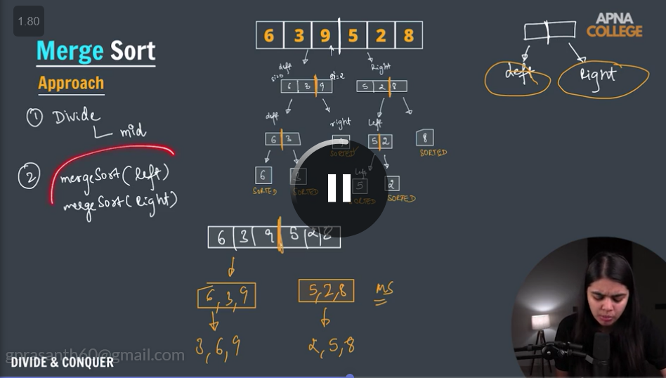

>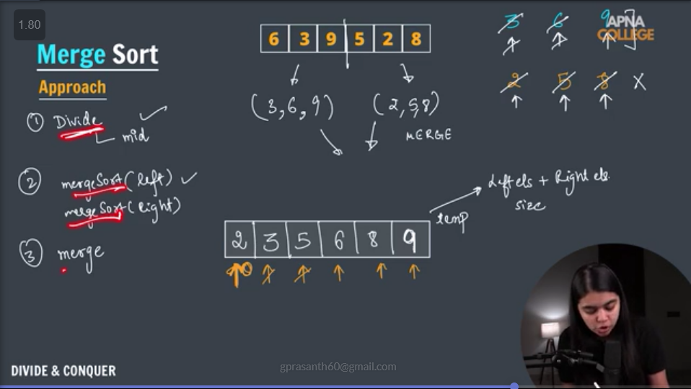

>imp **

>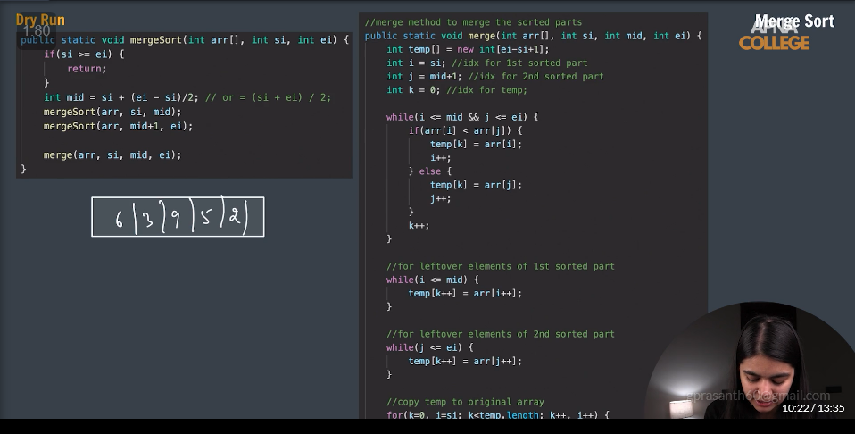

>base case

> for divide left and right .. two recursive calling one from si to mid and mid to ei

> send that to merge function

> create one temp array and 3 variables and two while loops one for left array checking and one right array checking and two more while for rest of elements to add and one super for loop for copying to temp to array to original array

Quick Sort:

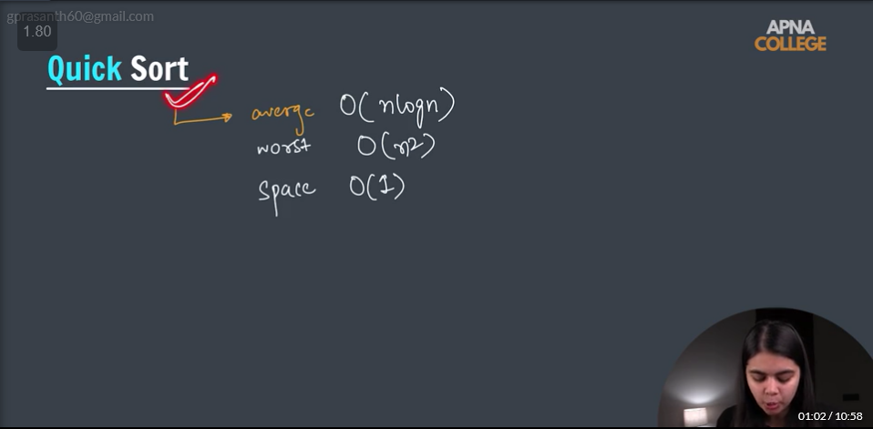

>Worst case in quicksort is when pivot element is the smallest or the largest number.

> Search in rotated sorted array(modified binary search)

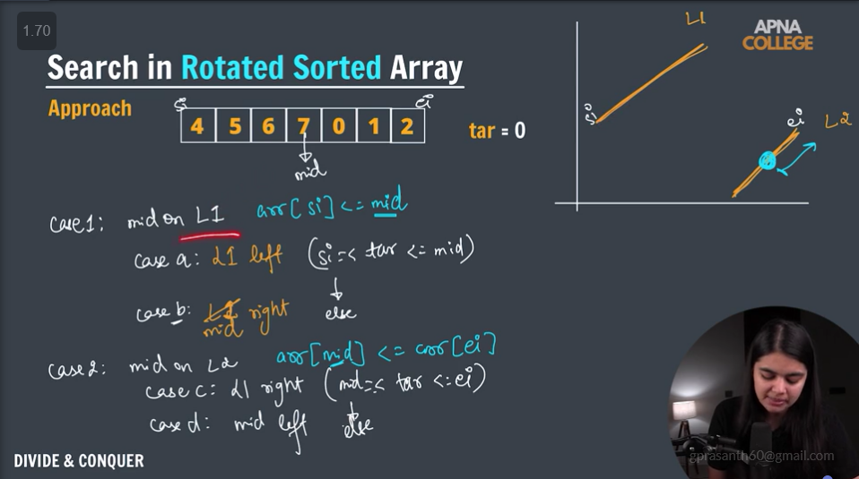

>Backtracking:

>the number subsets we can have are 2^n , where is the length of the array.

>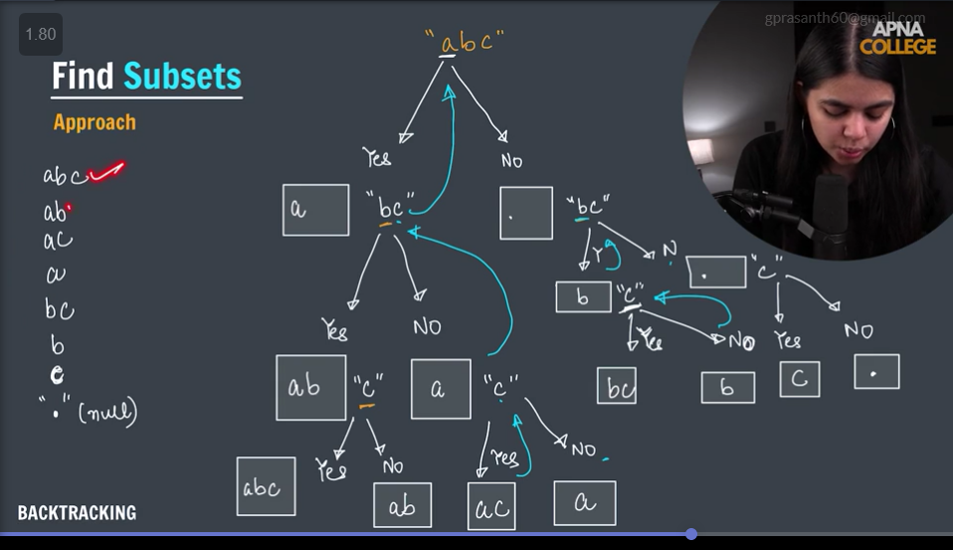

>number of permutations from the string length n , is equal to n!

—--------------------

>Nqueens

TC = o(n!) =